Test Case: tc003_SPX_Dev5_Crear_Requisicion_Spot_Tipo_Cobro_CC_Urgent
Step 1 - Enter username and password and click to button Enter : Credentials Entered
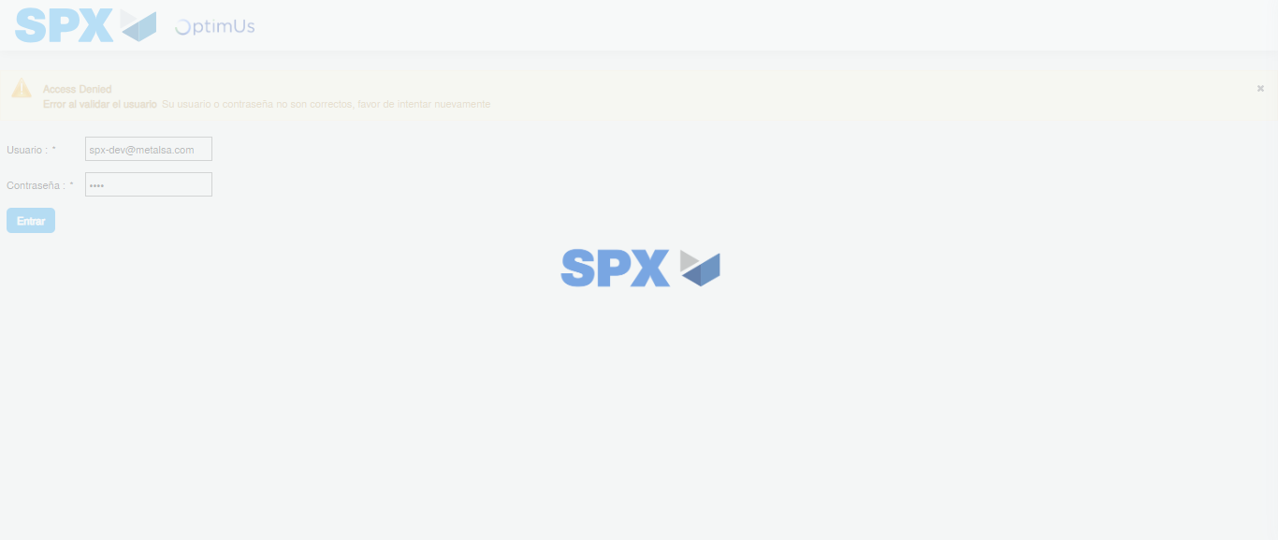Image file-name: QC_Testing-tc003_SPX_Dev5_Crear_Requisicion_Spot_Tipo_Cobro_CC_Urgent-1785961336593

Step 2 - Select to UEN and Access to Spot Buy Requisitions : UEN Correctly selected and Correct access
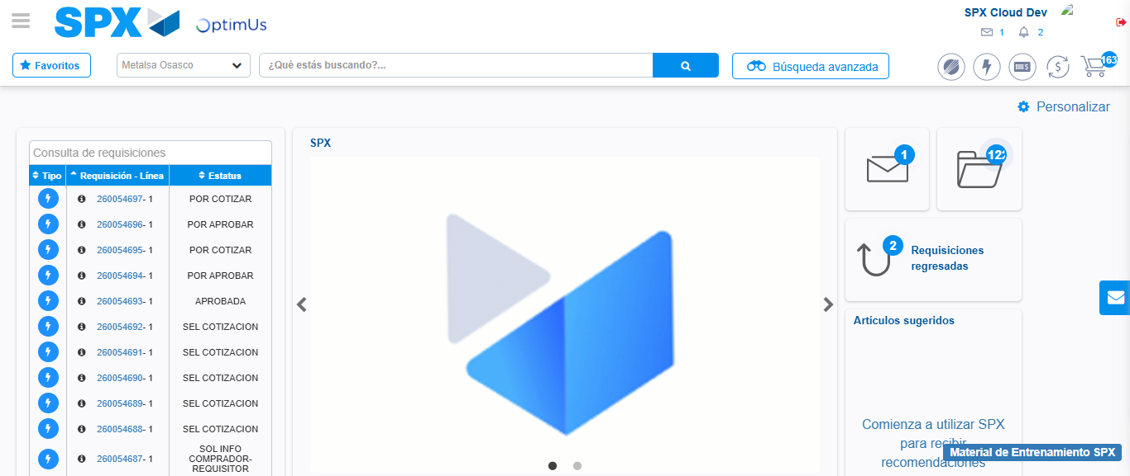Image file-name: QC_Testing-tc003_SPX_Dev5_Crear_Requisicion_Spot_Tipo_Cobro_CC_Urgent-1785961361646

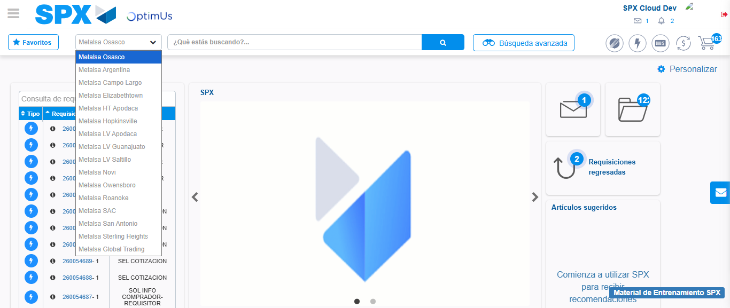Image file-name: QC_Testing-tc003_SPX_Dev5_Crear_Requisicion_Spot_Tipo_Cobro_CC_Urgent-1785961364296

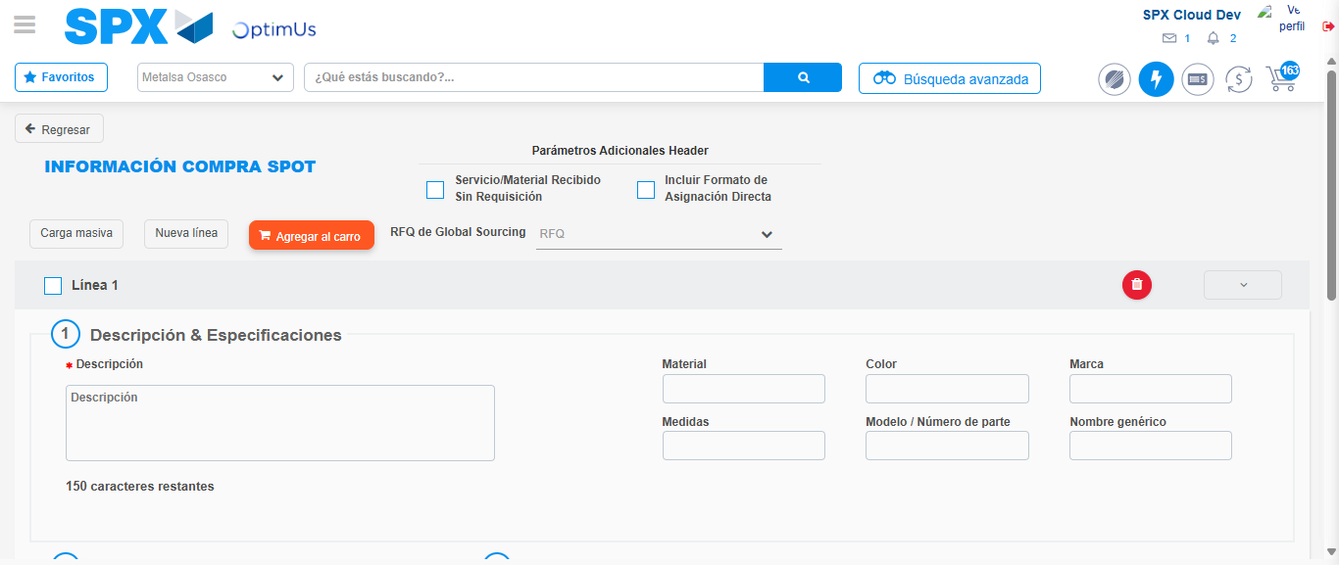Image file-name: QC_Testing-tc003_SPX_Dev5_Crear_Requisicion_Spot_Tipo_Cobro_CC_Urgent-1785961374422

Step 3 - Data Capture Spot Buy Requisition: Data captured correctly
Image file-name: QC_Testing-tc003_SPX_Dev5_Crear_Requisicion_Spot_Tipo_Cobro_CC_Urgent-1785961374647

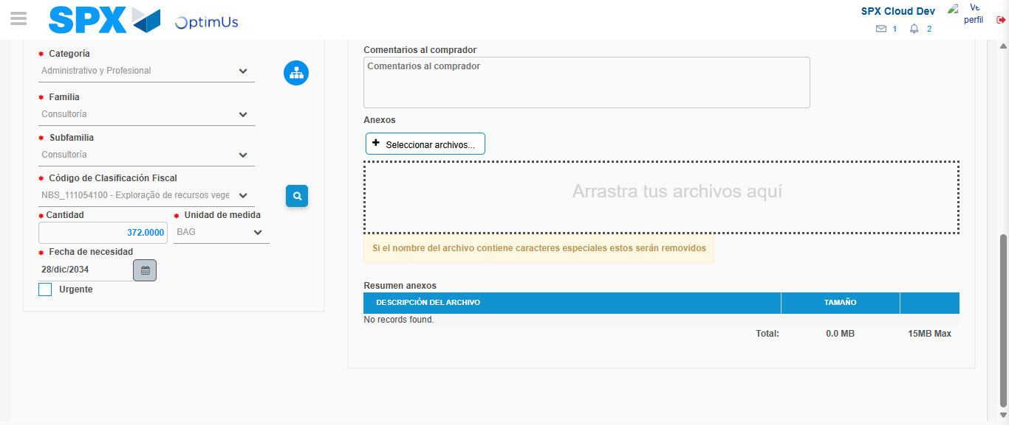Image file-name: QC_Testing-tc003_SPX_Dev5_Crear_Requisicion_Spot_Tipo_Cobro_CC_Urgent-1785961389536

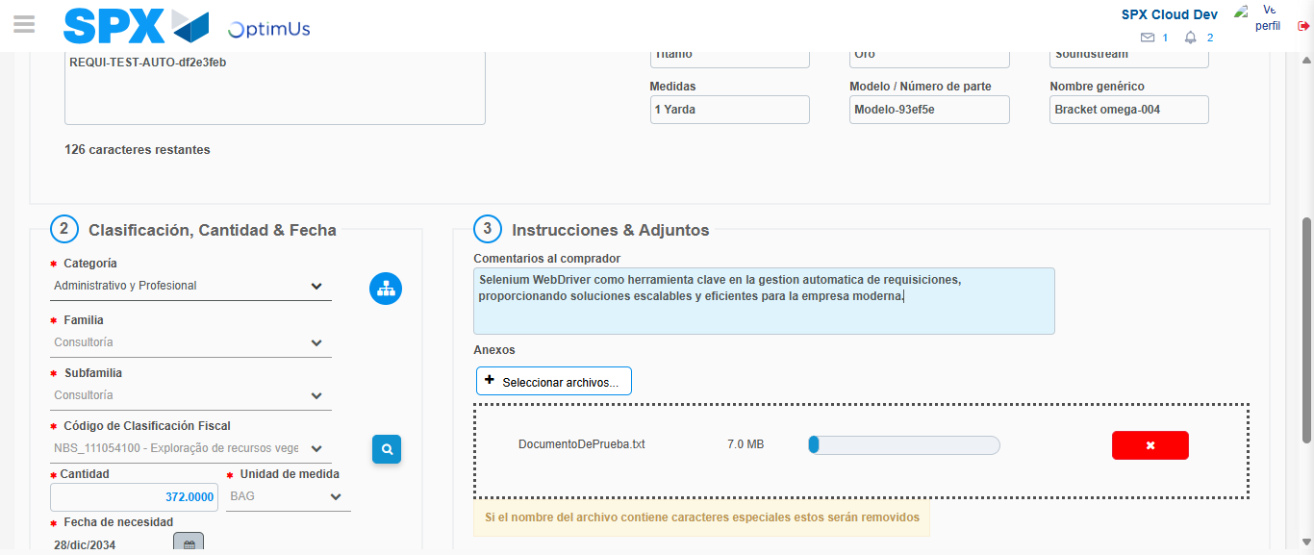Image file-name: QC_Testing-tc003_SPX_Dev5_Crear_Requisicion_Spot_Tipo_Cobro_CC_Urgent-1785961390281

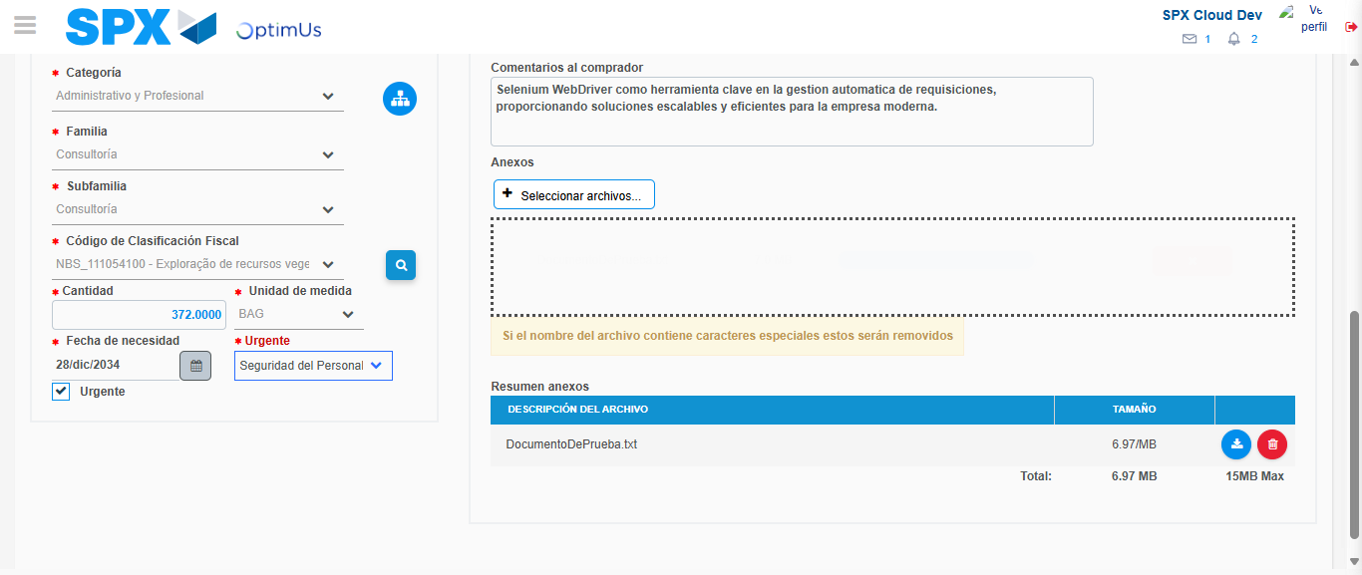Image file-name: QC_Testing-tc003_SPX_Dev5_Crear_Requisicion_Spot_Tipo_Cobro_CC_Urgent-1785961393940

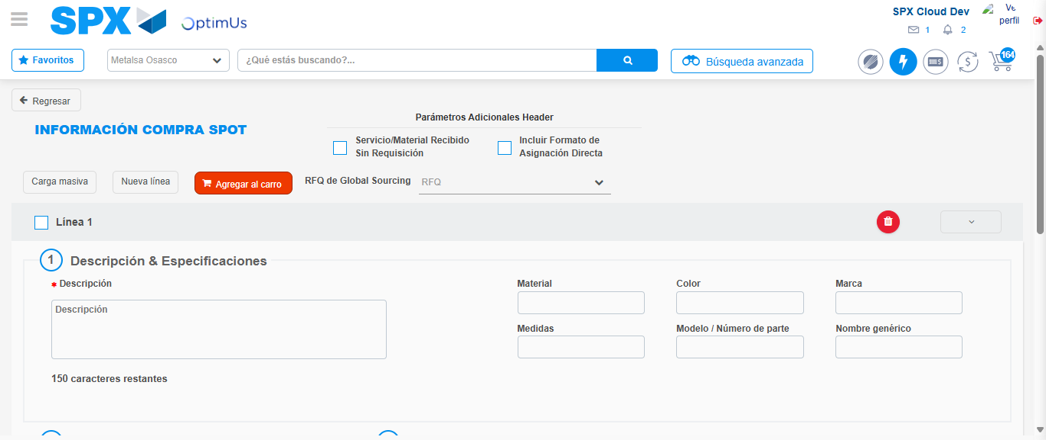Image file-name: QC_Testing-tc003_SPX_Dev5_Crear_Requisicion_Spot_Tipo_Cobro_CC_Urgent-1785961406476

Step 7 - Return to Main Page SPX : Return to Main Page SPX
Image file-name: QC_Testing-tc003_SPX_Dev5_Crear_Requisicion_Spot_Tipo_Cobro_CC_Urgent-1785961361646

Image file-name: QC_Testing-tc003_SPX_Dev5_Crear_Requisicion_Spot_Tipo_Cobro_CC_Urgent-1785961364296

Image file-name: QC_Testing-tc003_SPX_Dev5_Crear_Requisicion_Spot_Tipo_Cobro_CC_Urgent-1785961374422

Image file-name: QC_Testing-tc003_SPX_Dev5_Crear_Requisicion_Spot_Tipo_Cobro_CC_Urgent-1785961408698

Image file-name: QC_Testing-tc003_SPX_Dev5_Crear_Requisicion_Spot_Tipo_Cobro_CC_Urgent-1785961408882

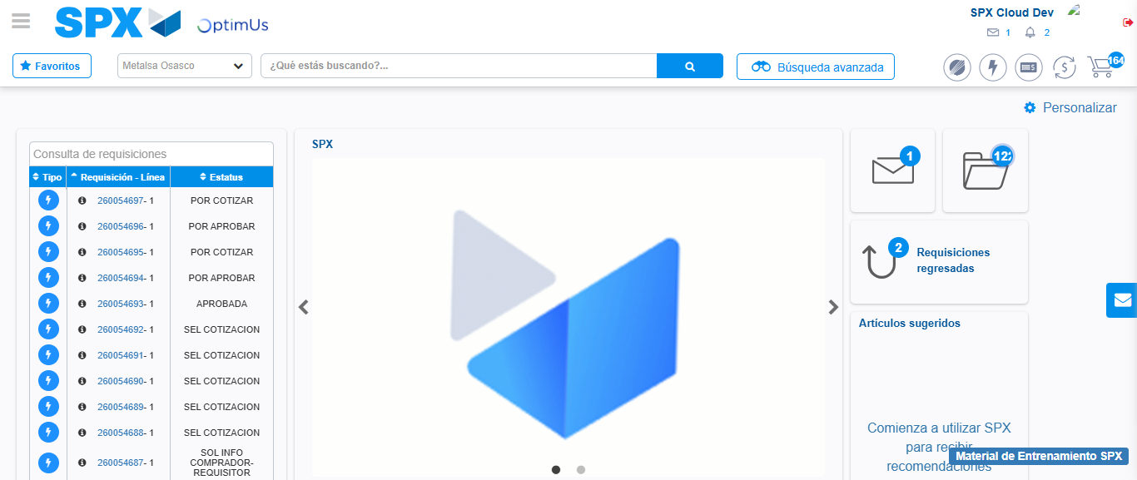Image file-name: QC_Testing-tc003_SPX_Dev5_Crear_Requisicion_Spot_Tipo_Cobro_CC_Urgent-1785961429890

Step 8 - Log Out : Log Out SPX
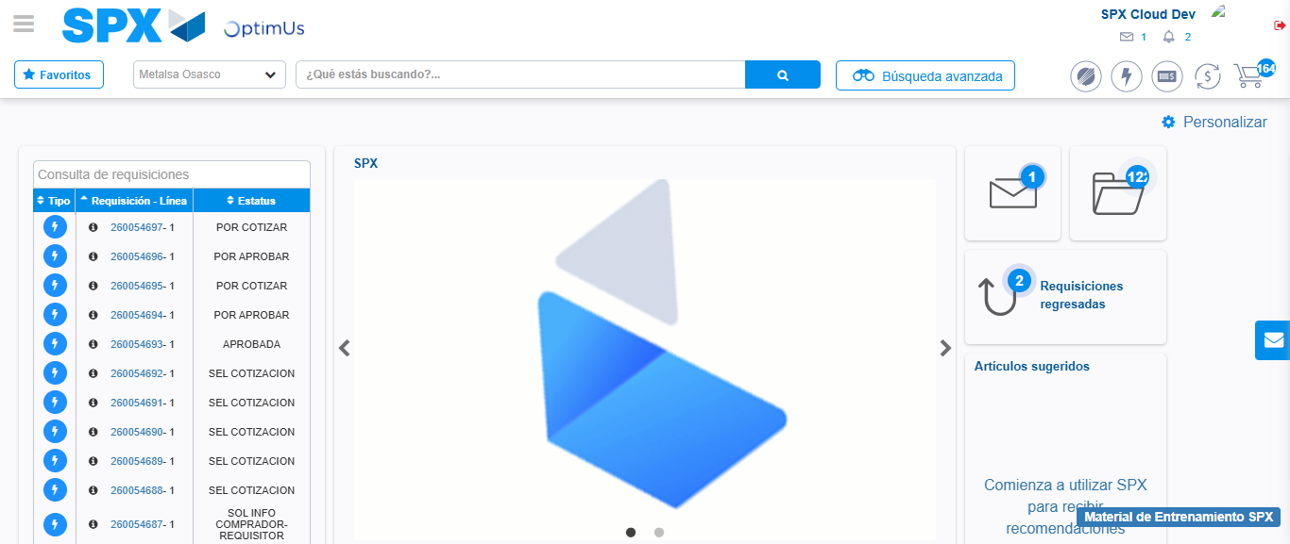Image file-name: QC_Testing-tc003_SPX_Dev5_Crear_Requisicion_Spot_Tipo_Cobro_CC_Urgent-1785961430174

